LAB # 02

INTRODUCTION TO MSP43O MCU AND INSTALLATIONS OF HARDWARE

AND SOFTWARE TOOLS



Spring 2025

CSE-307L

Microprocessor Based System Design Lab

Submitted by: Naveed Ahmad

Registration No.: 22PWCSE2165

Class Section: B

Student Signature: ______________

Submitted to:

Engr. Shah Zada Fahim Jan

March 08, 2025

Department of Computer Systems Engineering

University of Engineering and Technology, Peshawar

# Task 1

**Write a program for MSP-430 which toggle P1.0 or any other pin of MSP-430 MCU Code:**

**Output:**

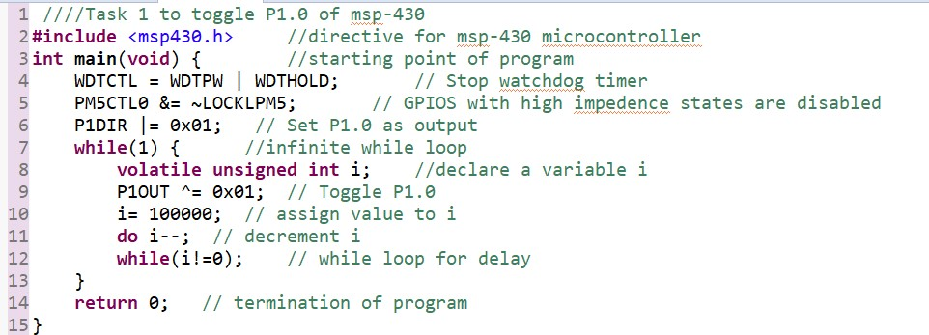

# Task 2

**Write a program for MSP-430 which toggle LEDs attached with P1.0 and P1.7 at the same time with different delays.**

**Code:**

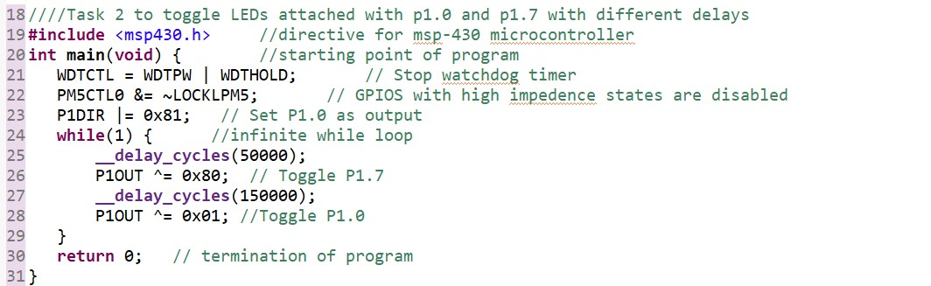

**Output:**

# Task 3

**Write a program for MSP-430 to toggle all the LEDs attached with P1 or any other PORT**

**Code:**

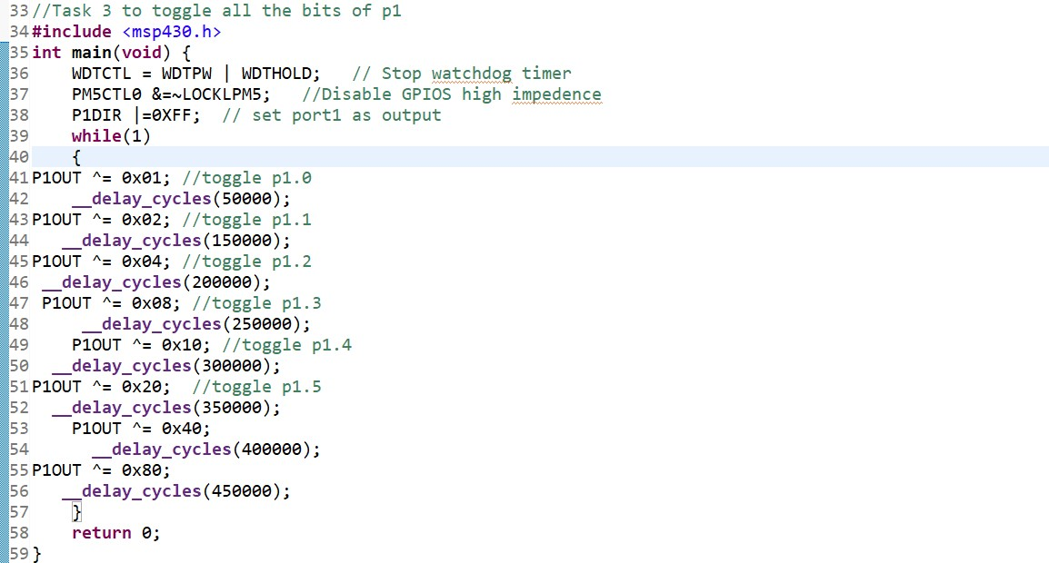

**Output:**

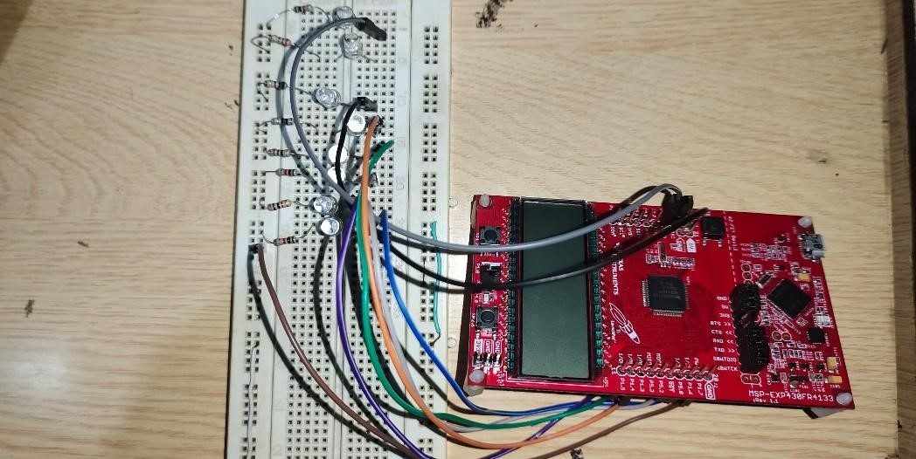

# Task 4

**Display the pattern using C language 00000001 00000010 00000100 …. 10000000 00000001 00000010 Continuously Code:**

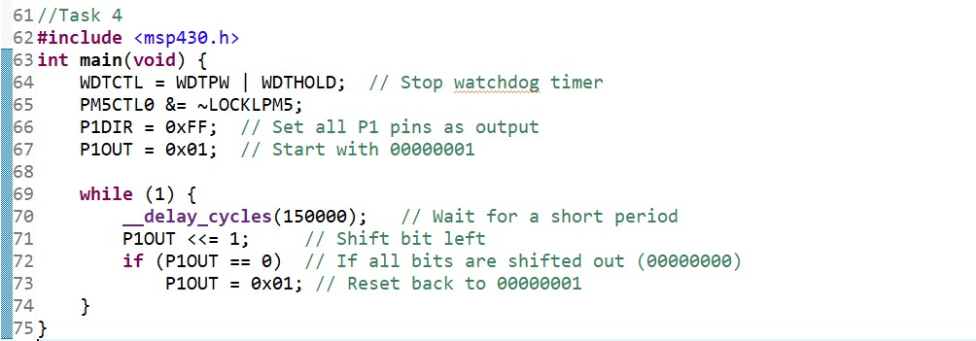

**Output:**

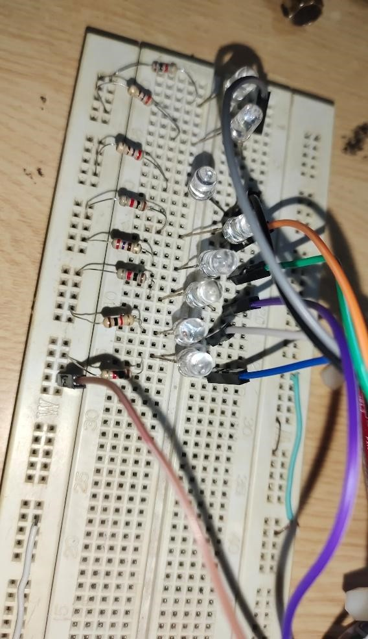

# *****END OF LAB 02*****